CS 255 System Design Document Template

This template lays out all the different sections that you need to complete for Project Two. Each section has guidance to prompt your thinking. You will need to continually reference the interview transcript as you work to make sure that you are addressing your client’s needs. There is no required length for the final document. Instead the goal is to complete each section based on what your client’s needs are. Remove this note when you are finished, and replace all bracketed text with the relevant information.

UML Diagrams

UML Use Case Diagram
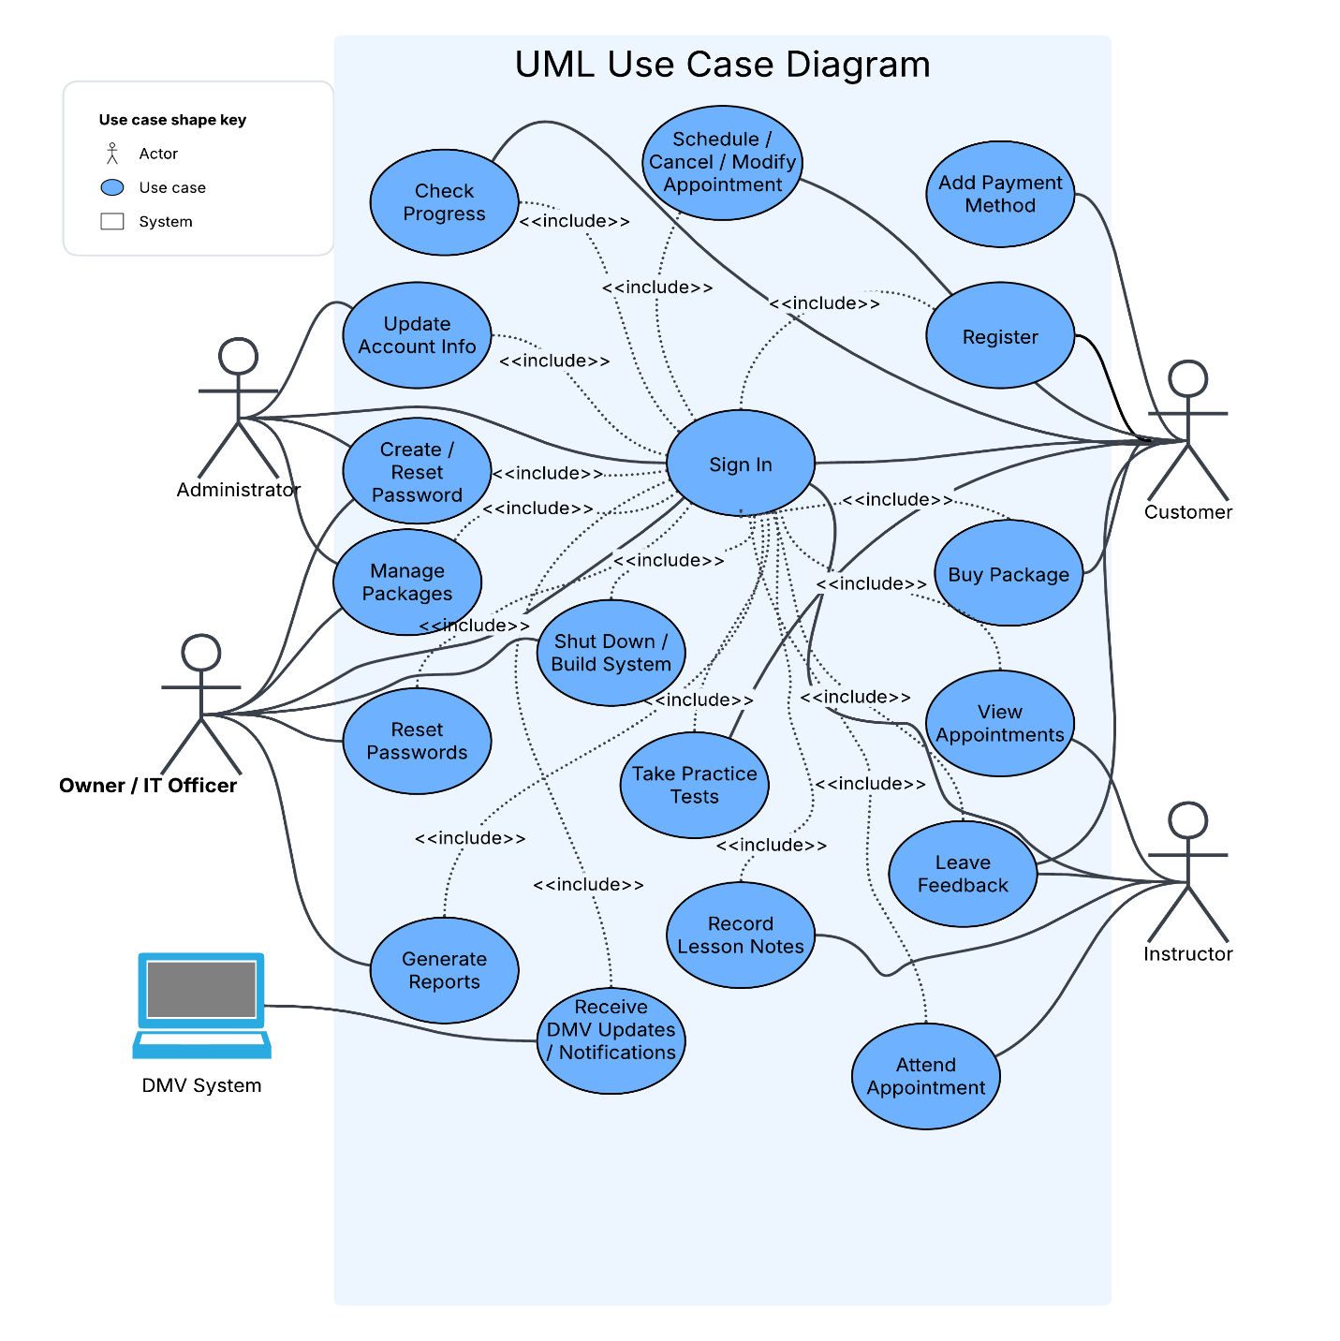

UML Activity Diagrams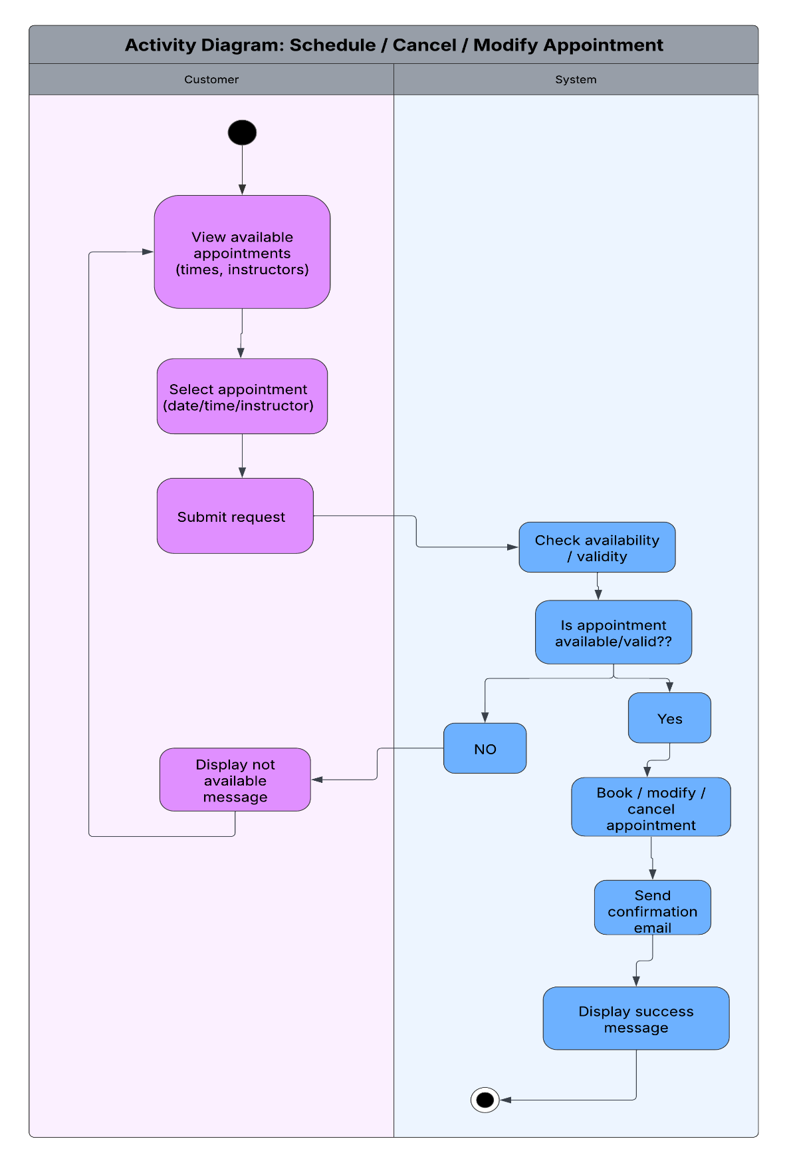

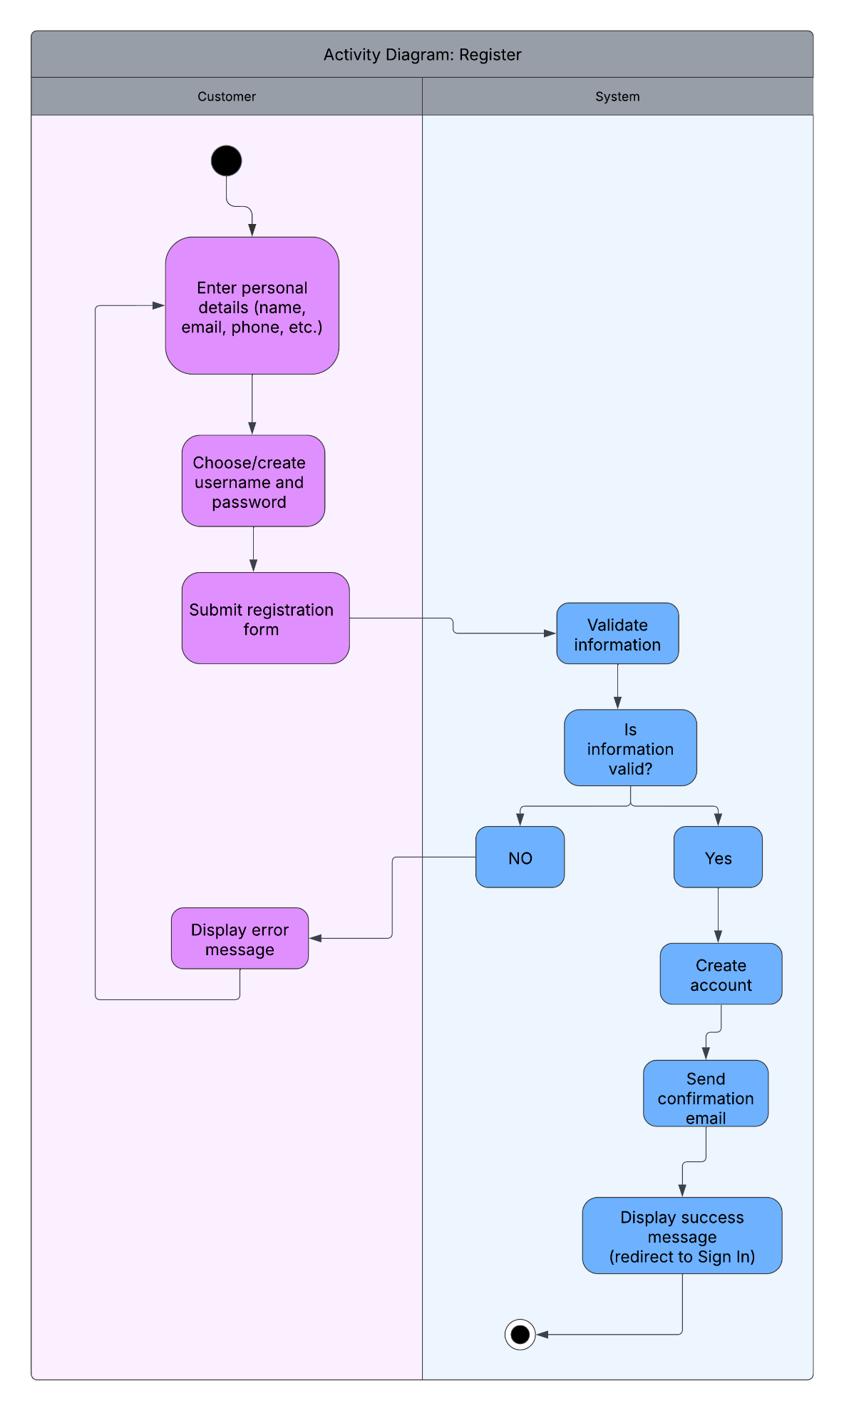

UML Sequence Diagram
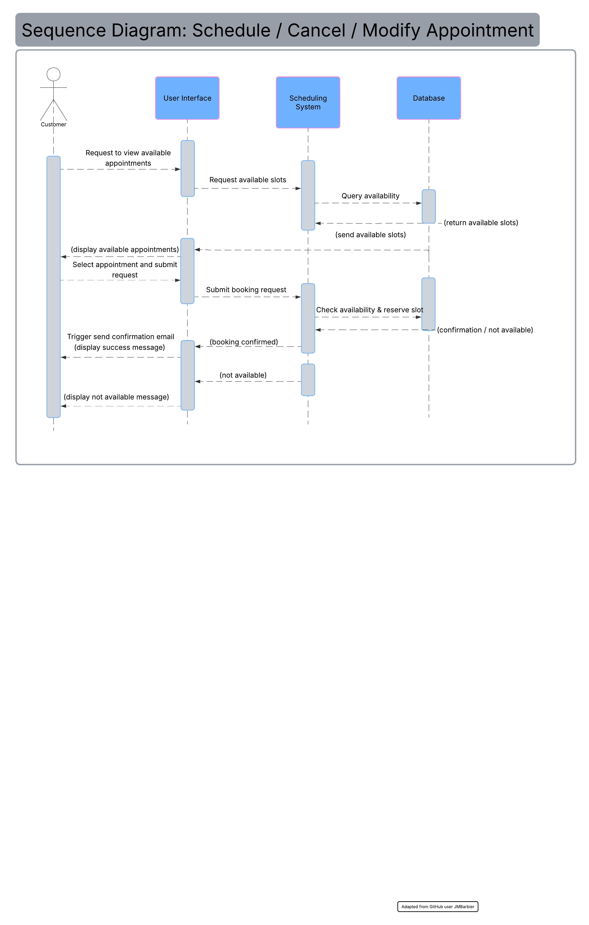

UML Class Diagram
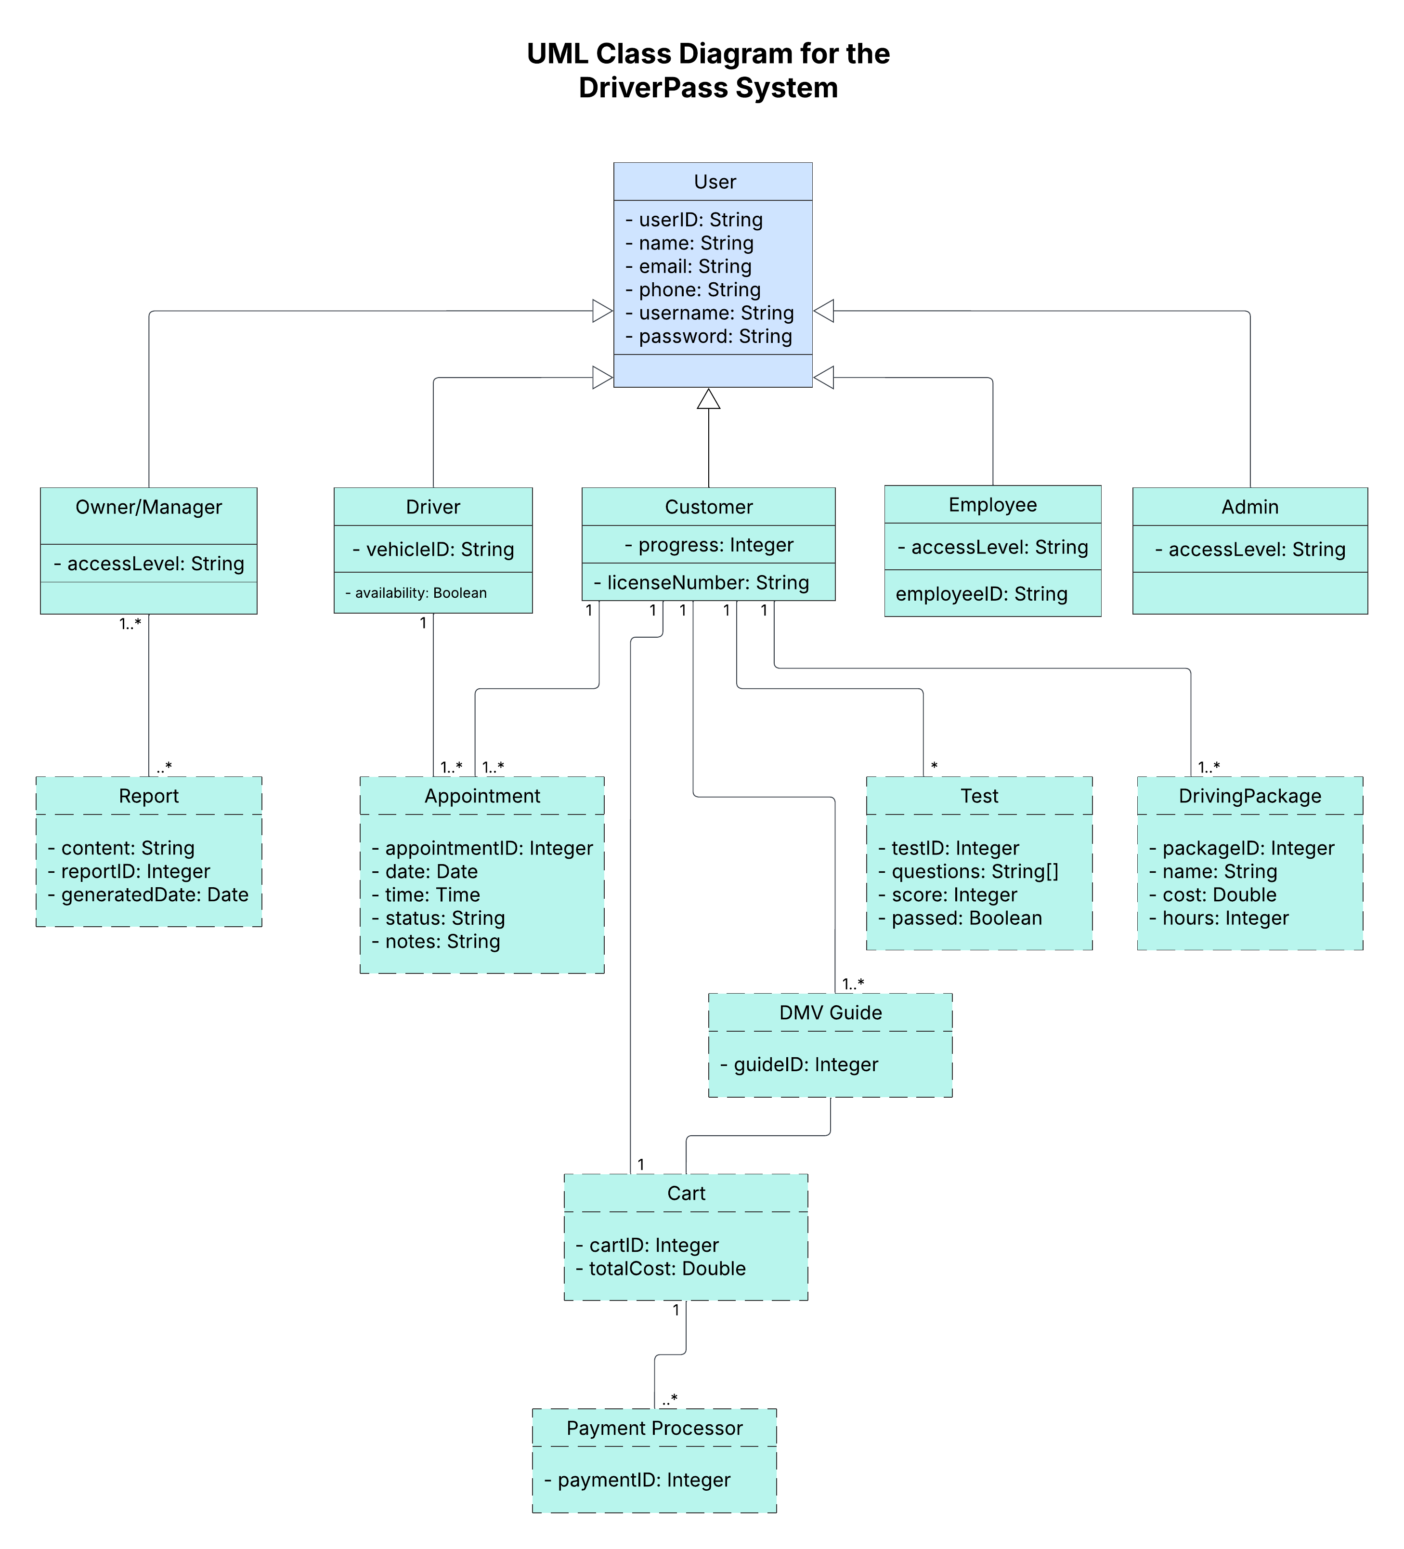

Technical Requirements

The DriverPass system is a web-based application designed for a small business with potential for growth. To support user registration, appointment scheduling, package purchasing, online practice tests, and administrative reporting, the following technical requirements are recommended.
Hardware Requirements
- Cloud-based or dedicated web server with multi-core processor, at least 8 GB RAM, and SSD storage to handle concurrent users and appointment availability checks.
- Computers for administrative staff (Owner, Admin, Employee) running Windows or MacOS for system management and report generation.
- Client devices: Standard desktops, laptops, tablets, or smartphones for customers and drivers (no special hardware needed).
Software Requirements
- Frontend: HTML5, CSS3, and JavaScript with a responsive framework (e.g., Bootstrap) to ensure the web portal is accessible on common operating systems including Windows, MacOS, iOS, and Android.
- Backend: Server-side technology such as Python (Django/Flask) or Node.js to manage user authentication, role-based access, appointment scheduling, and package/test logic.
- Database: Relational database (e.g., MySQL or PostgreSQL) to store user profiles, appointments, driving packages, practice test results, and reports.
- Additional: Email service for confirmation notifications and security software for virus protection.
Infrastructure and Tools
- Cloud hosting platform (e.g., AWS, Azure, or Heroku) for cost-effective scalability, automatic backups of sensitive customer and administrative data, and high availability.
- Reliable high-speed internet connection for all administrative members to access real-time updates on schedules, reservations, and DMV policy changes.
- SSL/TLS encryption for secure data transmission and role-based access control to protect user information.
This setup ensures the system is secure, expandable, and accessible to a wide customer base while supporting DriverPass's operational needs.

